THREE ADDRESS CODE TO TARGET CODE GENERATION
C Programming Lab Record
Student Details
Name | Sama Vaishnavi
Register Number | 192372117
Course / Subject | C Programming – Code Generation

Aim
To write a C program that converts Three Address Code (TAC) into target machine instructions using MOV, ADD, SUB, MUL, and DIV.
Program
#include <stdio.h>
#include <string.h>

int main() {
char result[20], op1[20], op[5], op2[20];

printf("Enter TAC (e.g., t1 = b + c):\n");
scanf("%19s = %19s %4s %19s", result, op1, op, op2);

printf("\nTarget Machine Code:\n");
printf("MOV R0, %s\n", op1);

if (strcmp(op, "+") == 0)
printf("ADD R0, %s\n", op2);
else if (strcmp(op, "-") == 0)
printf("SUB R0, %s\n", op2);
else if (strcmp(op, "*") == 0)
printf("MUL R0, %s\n", op2);
else if (strcmp(op, "/") == 0)
printf("DIV R0, %s\n", op2);
else {
printf("Invalid operator\n");
return 1;
}

printf("MOV %s, R0\n", result);
return 0;
}
Sample Input
t1 = b + c
a = t1
Output Screenshot
The following screenshot shows the output in OnlineGDB.
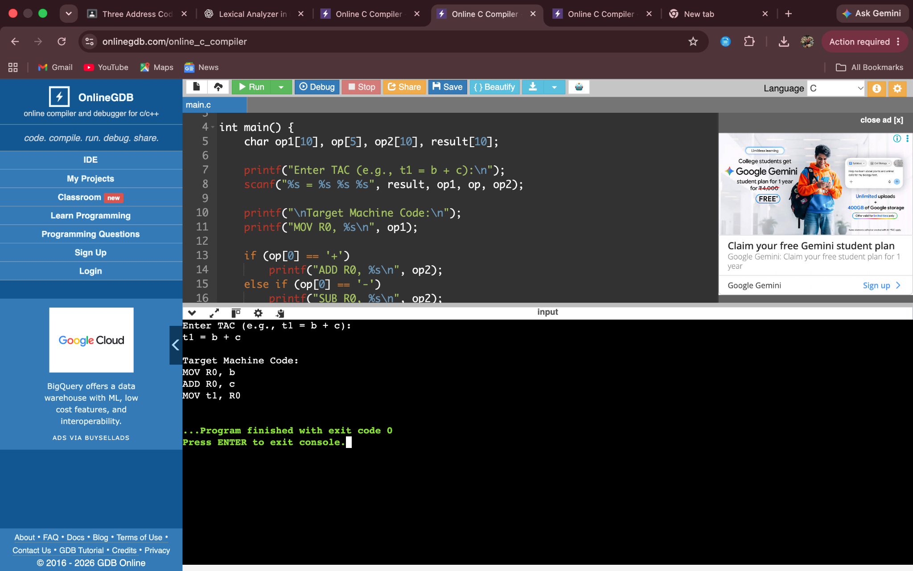
Expected Output
Enter TAC (e.g., t1 = b + c):
t1 = b + c
Target Machine Code:
MOV R0, b
ADD R0, c
MOV t1, R0

Result
The C program successfully converts the arithmetic TAC statement into target machine instructions. It uses MOV to load and store values and the appropriate arithmetic instruction (ADD, SUB, MUL, or DIV) for the operator.

